# Computer Networks and Network Security

# Lab Assignment One

P1

1. Open CMD and enter the command:

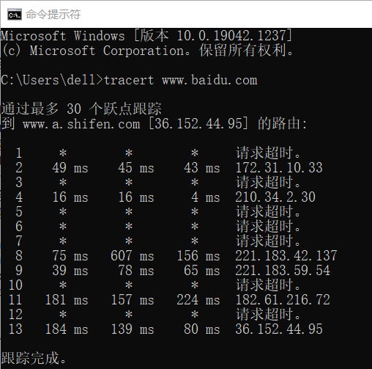

To find the largest number of hops, we check the result and find that the default hop count is 30, but there are actually only 13 hops. To verify this, we set the maximum hop count to be greater or less than 13.

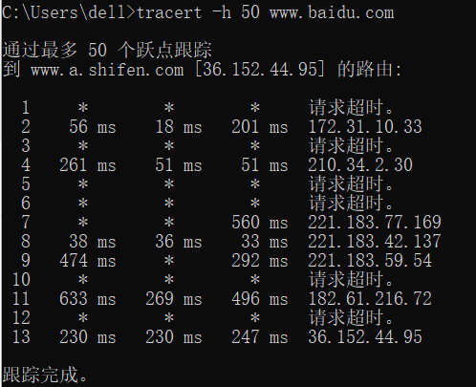

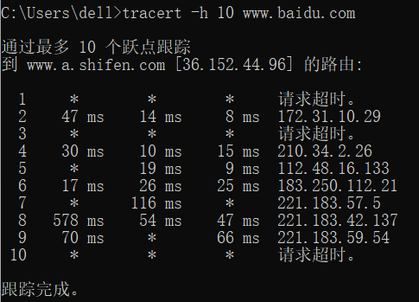

So the largest number of hops is 13.

1. Start Linux on the VM and enter the following command:

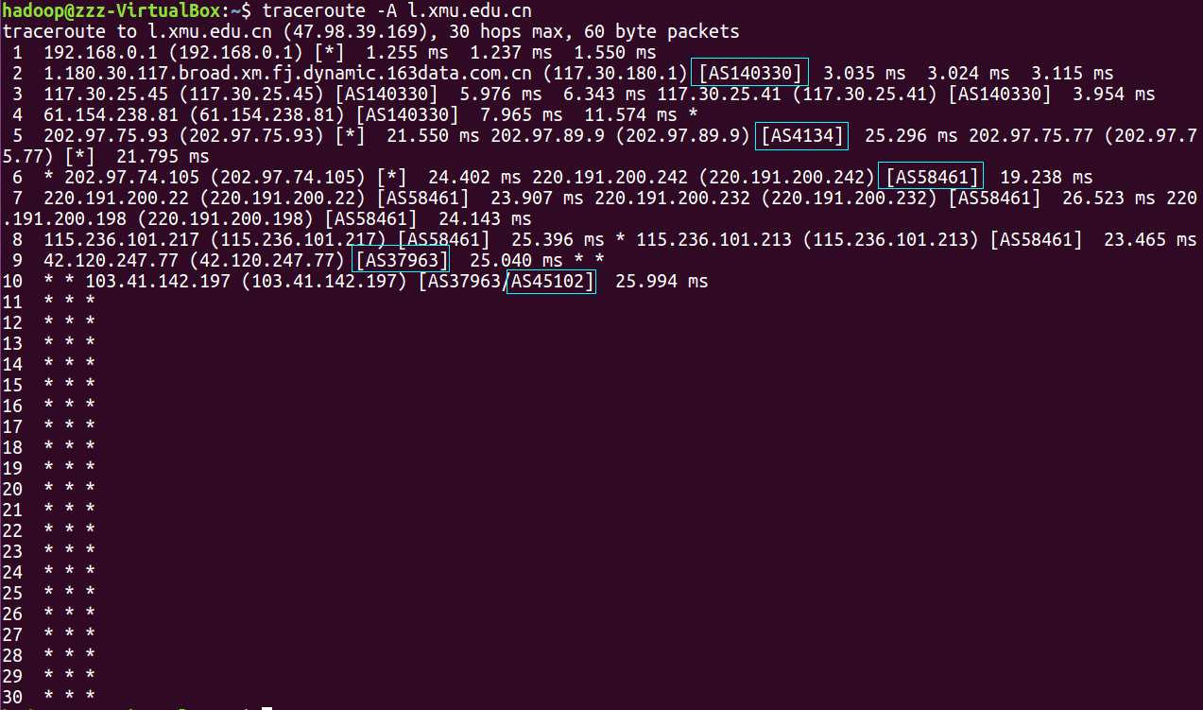

I have tried many different websites to find ISPs as many as possible,such as cctv, baidu, and so on. Finally, my school website gets the most ISPs.

P2

∵



∴

∵ ${(1+k)!*e}^{125}=100*{125}^{(k+1)}$

P3

Because it takes a core on average 200 ms to serve a Web request, when the following occurs:

A.a quad-core processor:

for a single request: 200ms/4=50ms;

total cost: 50*15=750ms

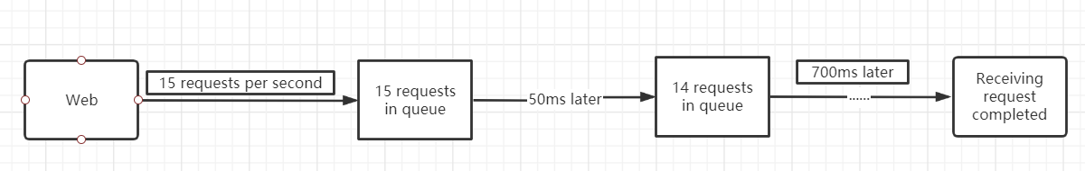

B.a dual-core processor:

for a single request: 200ms/2=100ms;

total cost: 100*15=1500ms=1.5s

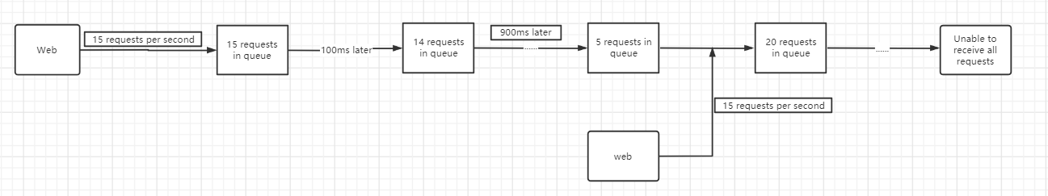

When the time passes by 1000ms, another 15 requests will be read in. Since the dual-core processor has not received all the requests of the previous group at this time, stacking will occur and the processing cannot be completed.

P4

a.Express the propagation delay, $d_{prop}$, in terms of m and s.

$$d_{prop}=m/s$$

b.Determine the transmission time of the packet, $d_{trans}$, in terms of L and R.

$$d_{trans}=L/R$$

c.Ignoring processing and queuing delays, obtain an expression for the  delay.

$$d_{end-to-end}=d_{prop}+d_{trans}=\frac{m}{s}+L/R$$

d.Suppose Host A begins to transmit the packet at time t = 0. At time t = $d_{trans}$, where is the last bit of the packet?

When t= $d_{trans}$, the last bit of the packet is just sent from A.

e.Suppose $d_{prop}$ is greater than dtrans. At time t = $d_{trans}$, where is the first bit of the packet?

∵t= $d_{trans}$ =L/R

∴ $d_{first}=s*t=sL/R$

So the first bit of the packet is at sL/R.

f.Suppose $d_{prop}$ is less than $d_{trans}$. At time t = $d_{trans}$, where is the first bit of the packet?

∵ $d_{prop}<d_{trans}$

Then t> $d_{prop}$

So the first bit of the packet has reached Host B.

g.Suppose s = 2.5 x 108, L = 120 bits, and R = 56 kbps. Find the distance m so that dprop equals dtrans.

$$d_{trans}=\frac{L}{R}=\frac{120}{56}*{10}^{-3}$$

$$∵d_{prop}=d_{trans}$$

$$∴\frac{m}{s}=\frac{L}{R}$$

$$\overset{⇒}{}m=\frac{L}{R}*s=\frac{120}{56}*2.5*{10}^{-3}*{10}^{8}=5.36*{10}^{5}$$

P5

1. Calculate the bandwidth-delay product, R · dprop.
$$R·d_{porp}=R*\frac{m}{s}=\left(2*{10}^{6}\right)*\left[\frac{20000*{10}^{3}}{2.5*{10}^{8}}\right]=1.6*{10}^{5}(bit/s)$$

2. Consider sending a file of 800,000 bits from Host A to Host B. Suppose the file is sent continuously as one large message. What is the maximum number of bits that will be in the link at any given time?

According to the first question, the maximum transmission bit is $1.6*{10}^{5}$.

1. Provide an interpretation of the bandwidth-delay product.

The bandwidth delay product refers to the product of the link bandwidth and the back-and-forth communication delay. Represents the maximum amount of data on the network at a specific time, that is, data that has been sent but not yet acknowledged.

1. What is the width (in meters) of a bit in the link? Is it longer than a football field?

$Width=\frac{20000*{10}^{3}}{1.6*{10}^{5}}=125$ m

However, a football field is 14 to 16 meters wide, the width is longer than it.

1. Derive a general expression for the width of a bit in terms of the propagation speed s, the transmission rate R, and the length of the link m.

$$Width=s/R$$

P6

From bits produces to decode：

Transmission time：

Total time：

P7

∵Transfer by link：

37 days is much more than one day, so I prefer to use FedEx over-night delivery.

P8

1. Choose circuit-switching network, because it maintains longer uptime and stability while occupying fewer idle resources.
2. No, because it is already assumed that the sum of the application's data transfer rates is less than the respective capacity of each link.

P9

1. The number of users：
2. Since each user takes only 10% of the time, the probability p=0.1；
3. 
4. 1-

P10

1. From the source host to the first packet switches：

From the source host to move the packet to the destination host：4*3=12s

1. From the source host to the first packet switches：

From the first switch to send the first packet to the second switch, from the source host sends a second grouped into the first switch：5ms

The second packet can be received by the first switch：10ms

1. After packet segmentation, only the arrival time of the last packet needs to be considered, that is:

Compared with (a), 4.01s<12s;

Explain: When a packet switch works, the packet can be forwarded only after the entire packet is received. When the packet is divided into many smaller packets, the forwarding efficiency is improved and the waiting time is greatly shortened.

1. When the file is large, packet segmentation can be used to divide large files into small files, reducing the pressure on the packet switch. In addition, if a transmission error occurs in a certain part, the packet can be directly retransmitted with little impact on the overall workload.
2. Because the cut packet needs to be marked new, the total size of the received file is larger than that of the original file.

P11

The time of arrival of the first group：

∴t==

=≥

If and only if ，S has a minimum.

∴S=

P12

Skype uses a professional voice gateway for signaling conversion, and then restores the converted message to voice over the operator's line for outgoing calls.